**User Guide**

**Steps to run the application**

1. Log on to clever cloud. Open PHP MyAdmin Console.

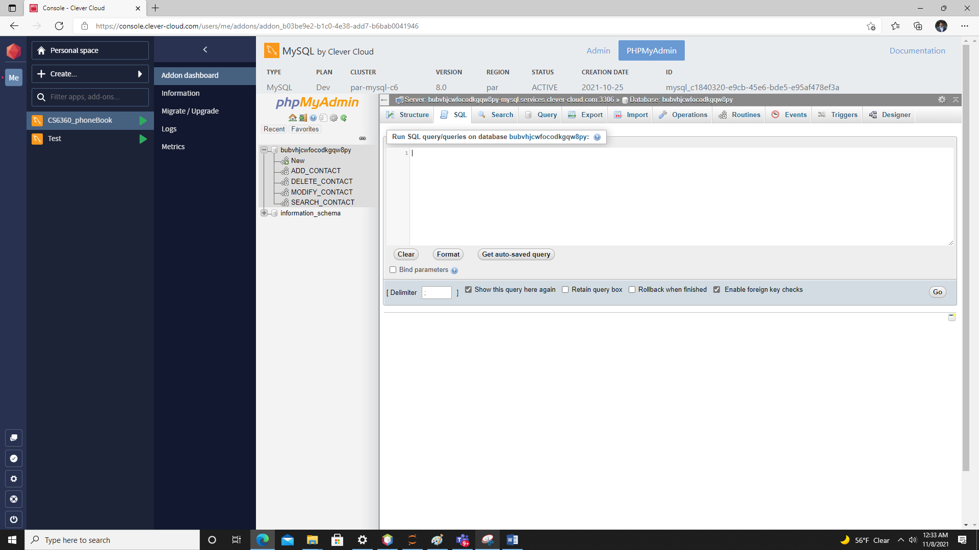

1. Run csvTablePopulation.java program.

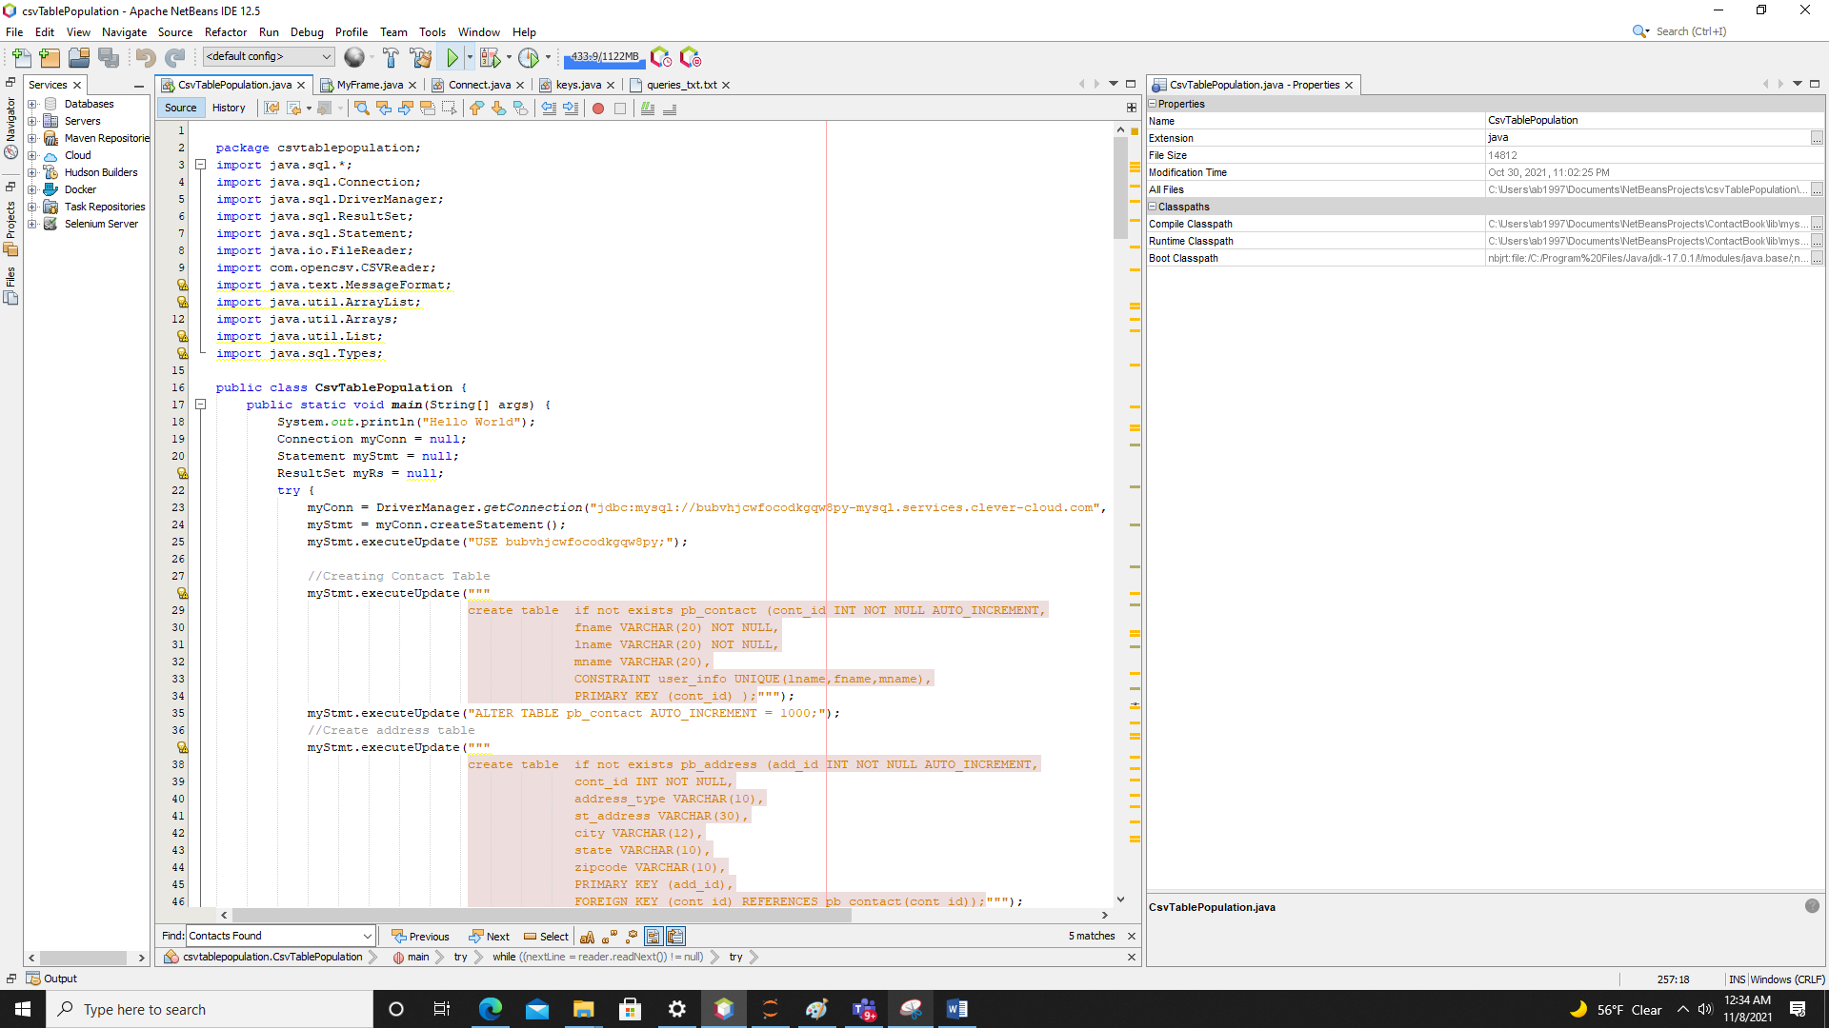

1. Tables have been created and populated on the SQL server

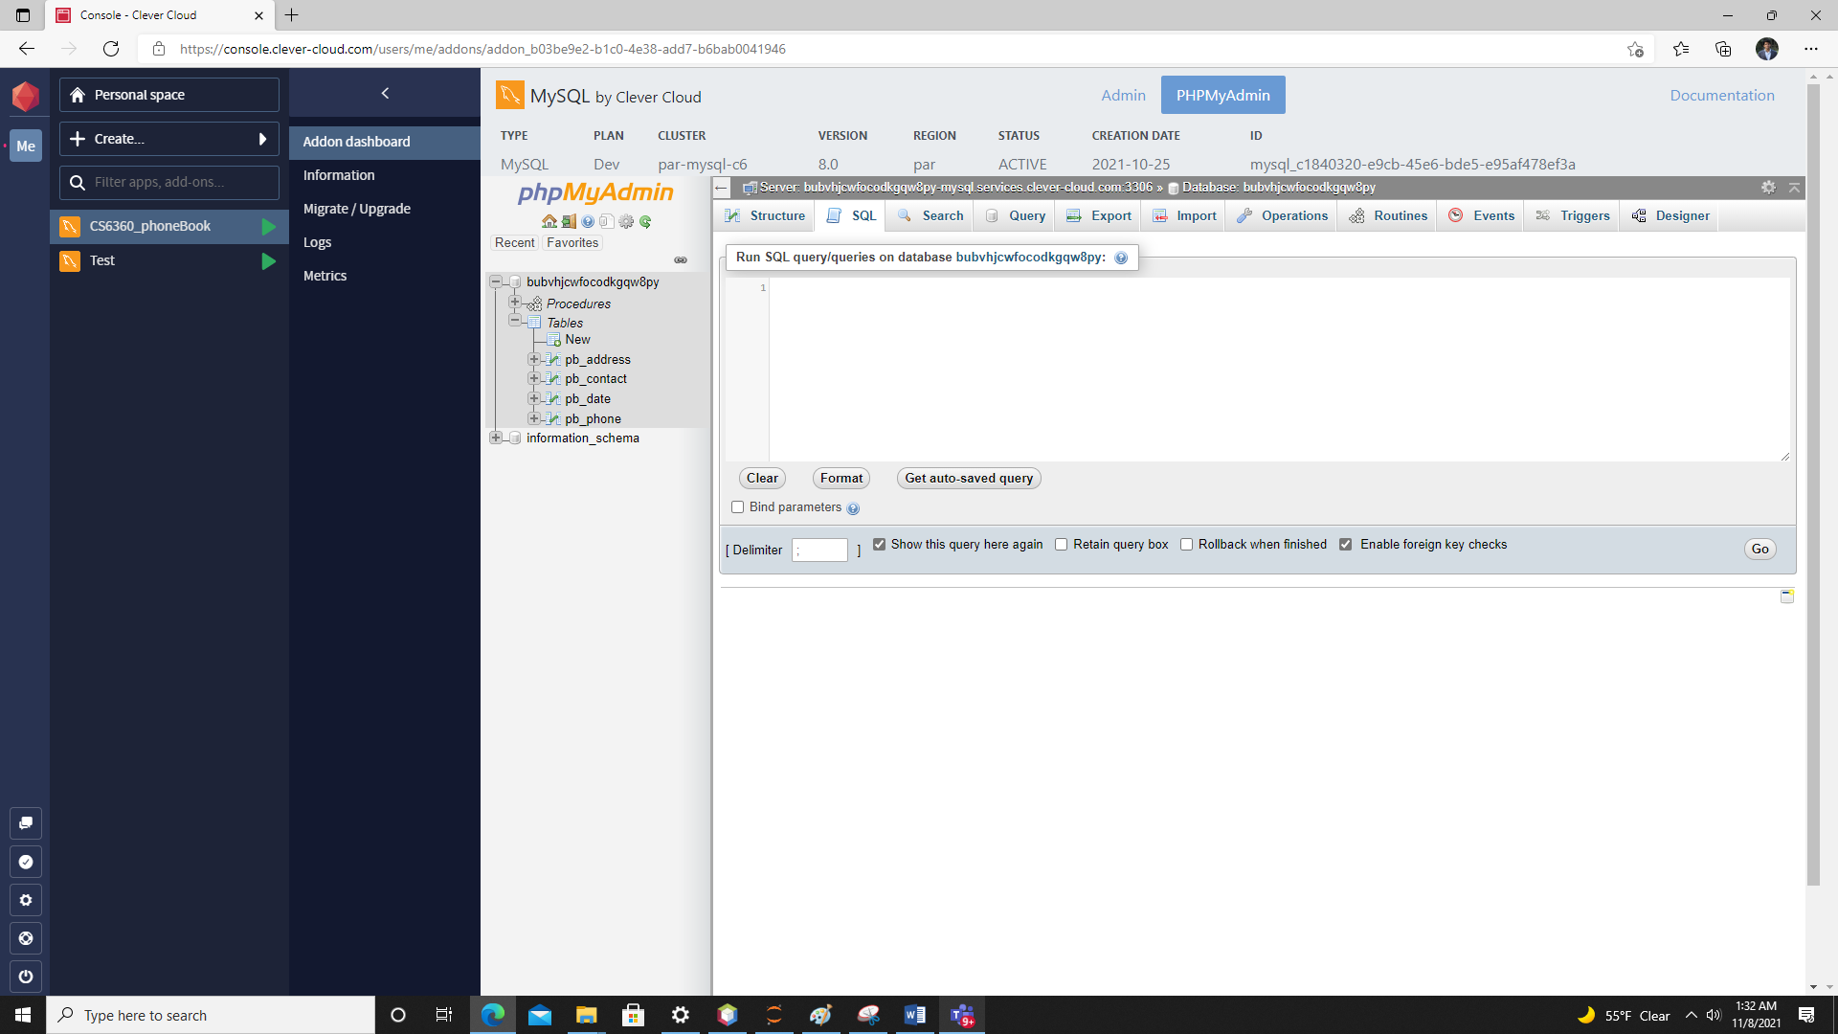

1. Build, Compile and Run MyFrame.java program to launch the phonebook application:

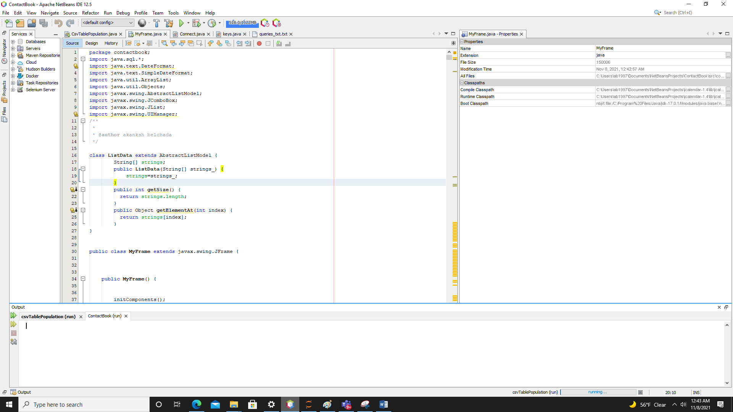

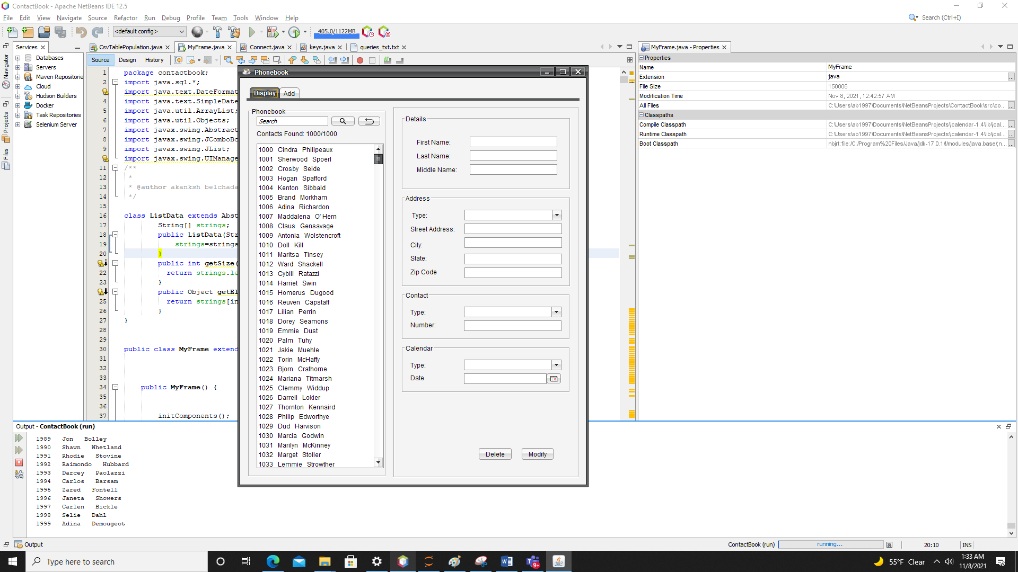

**Using the phonebook application**

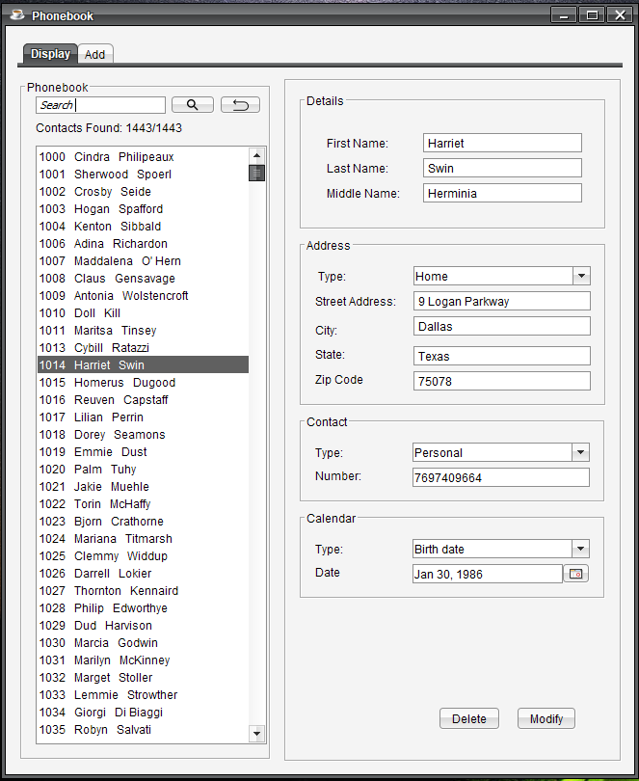

Display Tab

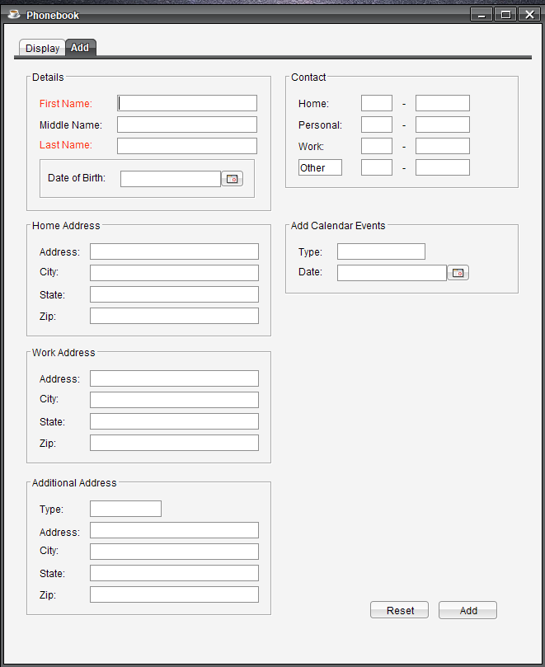

Add Tab

1. The phonebook application has two tabbed windows; **Add** and **Display** (*self explanatory functions*).
2. The **Display** window features a scrollable list which displays the [ Contact id First-name Last-name] for all the contacts stored on the database server. Clicking on one of these contacts would enable user to see the fields on the RHS to be populated with the corresponding values.
3. The **search** bar enables users to search any string (which might occur in any of the details of a particular contact record) and the matching searches get displayed in the scrollable list.
4. **The Contacts Found:** label indicates the total number of searchs found. When the **back** button is pressed right next to the **search magnifiying glass**, the count of the total contacts storedon the application gets displayed.
5. The contact details fields on the RHS of the scrollable list display the values of the corresponding to the contact record.  
    The **Address Type** dropdown displays all the address types of the contact which are stored in the application. Selecting one of these address types will autopopulate the StreetAddress, City, State, Zipcode corresponding to that address type.

The **Contact Type** and **Calendar Type** dropdowns perform similar functions as the **Address Type** dropdown.

1. The **Delete** button at the bottom of the window deletes the entire contact card of the the selection.
2. The **Modify** button on the bottom of the window will modify the contact card with the new/updated values for each of the fields. The 3 **dropdowns** are editable; in order to add a new address-type/contact-type/calendar event-type, enter the desired type in the editable drop down and add the corresponding details.
3. The **Add** window features a form containing all the optional and mandatory fields. The **Add** button on the bottom is used to enter the contact record on the database.
4. The application alerts dialog prompts for any CRUD action performed by the user.
5. Form validation has not been programmed for the fields and it is expected that apt values for each of the fileds must be entered.

***